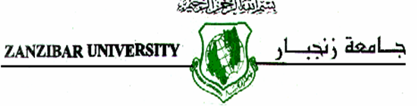

**FACULTY OF BUSINES ADMINISTRATION**

**DEPARTEMENT :** BUSINESS INFORMATION TECHNOLOGY

**LECTURER :** DR AMIR MWINYI

**SUBJECT :** HUMAN & COMPUTER INTERACTON

**NAMES OF STUDENTS** : AISHA FIKIH IDD

NIYONZI RAUFU

HASHIM MTELERAH HILAAL

ABDUL-KARIM SHARIF PHIRI

**YEAR OF STUDY :** SECOND YEAR

**SEMESTER :** ONE

**SUBMISION DATE:** January 27th, 2018.